Memory Type Synchronous On-chip Cache
Access Time 5 ns
Memory Size 64 Kbits
Line Size 4 x 32 bits
No of Lines 256
Associativity 2-way Set Associative
Data Width 32 bits
Address Width 32 bits
Tag Size 22 bits
Operating Voltage 1.8 V
Power Consumption <50mW
Process Type and Feature Size UMC 0.18μm mixed-mode
Core Efficiency Target >70%
Redundancy Not needed

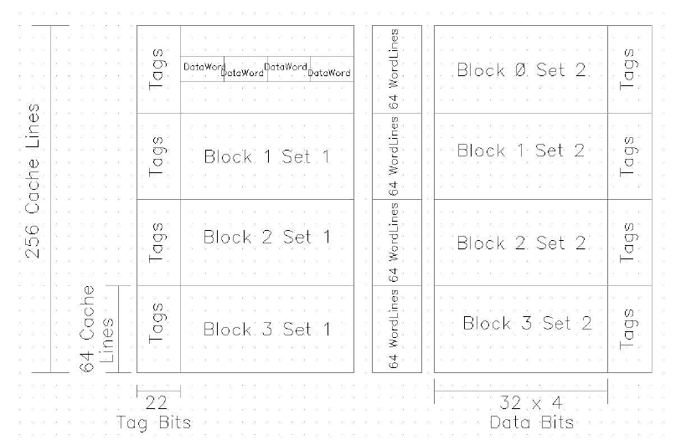
The data array of the cache has 256 lines of 4x32 bits each and there
are 2 sets of the cache. The number of address bits is 32 of which 10 bits
[AD<9:0>] are required to address the 32K bits of one set. The other set
shares the same address LS bits. Hence (32-10=22) bits [AD<31:10>] are
used as the tag bits.
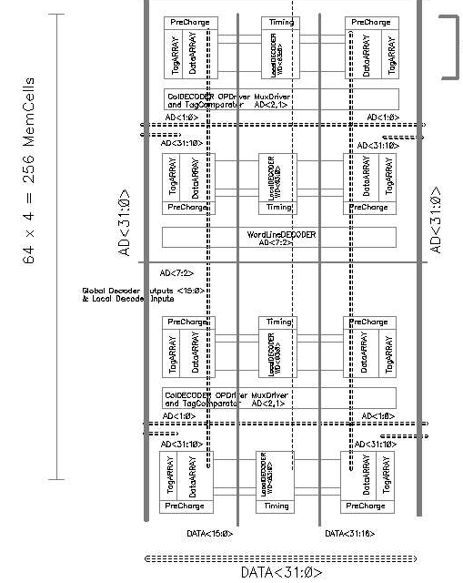
Basic Floor Plan

